

Department of Electrical and Computer Engineering

May 6th |  | Spring 2014

Discrete Mathematics

Computer Project #2

Group Members:
Hector Ramos

Map Class:
This is where the graph object itself is stored and created for the project. Map.cpp holds the relevant node and edge data and the means of retrieving the information by functions. How many edges connect two nodes is stored in a Matrix via a 2 dimensional array, “pathArray”. Each node in the graph was numerically chosen in the array by numbering each one, from top left to bottom right in the graph in ascending order. The matrix and nodes numbers are shown below:
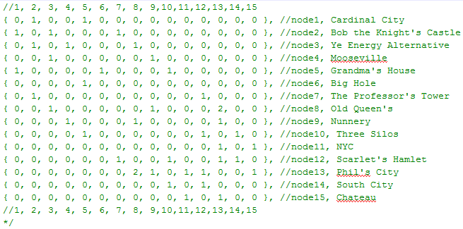
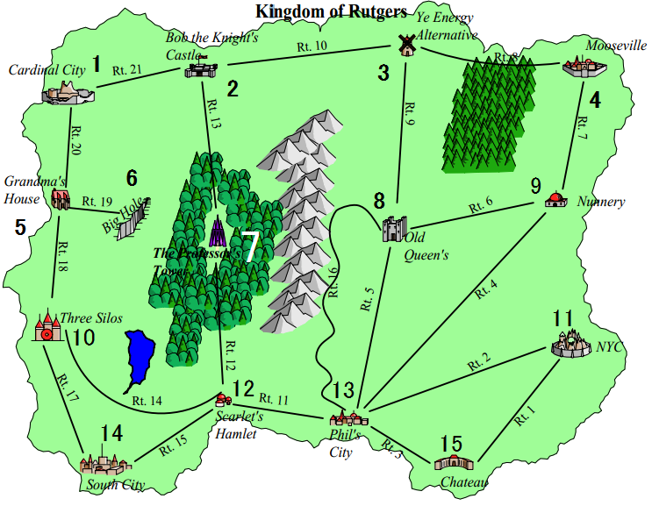
The matrix is created by declaring each element in the 2 dimensional array to 0, then declaring each element individually. Unfortunately the method of using curly braces to do it simply had to be abandoned due to the compiler having issues with having curly braces for array initialization within header/cpp files.
The edge data is stored within a struct array, the struct is shown below:
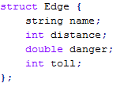
The struct contains 4 relevant parameters: name, distance, danger, and toll. The distance, danger and toll values correspond to the values within the table given by the project for routes for each respective edge. Name is the name of each edge struct object, which is very important for accessing the edge and obtaining the proper information via the get functions within the class. The naming of each edge does not correspond to the route numbers given by the tables in the project. Instead, each edge is named with a different convention, and assigned the proper values for their respective routes on the table in the code of the Map class.
The naming convention for each edge can be a bit confusing at first, but is overall rather simple. There are 21 edges overall in the graph given, and for this project the naming convention for each edge was decided to be in the format:
Edge <Node 1> <Node2>
So, for Rt.21 of the graph, the edge’s name would be called “Edge12”; Since it connects node 1 to node 2. Another example would be Rt.2, which connects Node 11 to Node 13, and is named “Edge1113”. It is also important to note that the numbers are listed alphabetically, meaning that if the first node of interest is Node 13, and the second node is node 2, there is no “Edge132” object --- instead it is “Edge213”, meaning that the edge’s nodes are sorted alphabetically for the naming convention for consistency.
This naming convention makes it very easy to be able to look up edges by entering the nodes of interest, however two routes on the graph poses a problem for this naming convention, routes 5 and 16, which connect node 8 and 13. This is the only case in the graph where two edges connect two nodes, and must be addressed. The naming convention for these two edges is supplemented by the appending the path number at the end of the naming convention:
Edge <Node 1> <Node 2> <Path #>
Since the path # is somewhat arbitrary, route 5 was set to “edge8131”, and route 16 was set to “edge8132”; this follows the naming convention previously, since nodes 8 and 13 are the nodes of interest, but it appends the “1” and “2” at the end to differentiate between the multiple paths offered. To help the later classes accessing the map class’ data for relevant node/edge information, the matrix shown above for pathArray stores the number of edges connecting the two nodes --- if the value is 2, the future functions of interest will run an algorithm to access both edges.
When the Map’s “getPath(int node1)” function is called, an integer Array is returned with the node’s respective row on the Matrix pathArray as shown above. This allows outside classes to call the function inputting the current node as a parameter and get the nodes connected to it and the # of edges connecting the nodes. For example, if the function map.getPath(1) is entered, the first row of the pathArray Matrix will be returned. This allows outside classes to know how many edges connect each respective node in the graph, and call future relevant functions to pull the necessary information from the Map class.
To pull edge information from the map class, there are 3 relevant functions: getDistance, getDanger, and getToll, as shown below:
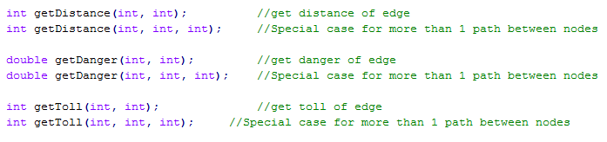
Each function is overloaded, to account for the case where there is more than one edge connecting the two nodes, which is decided outside of the Map class upon calling the function. To properly call the correct edge within the edgeArray, each function calls “orderNumerically”, which takes the two integer parameters entered and orders them numerically by changing their variables by reference:
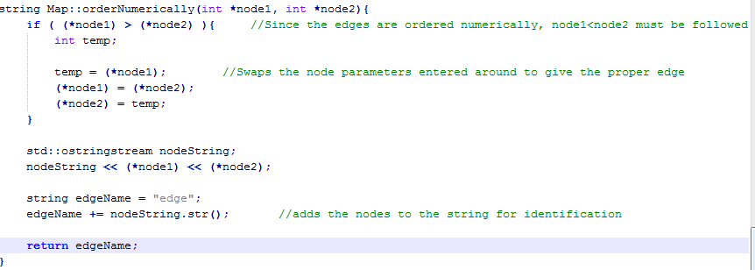
The function “orderNumerically” returns a string, edgeName, which follows the naming convention shown before to properly find the correct edge and acces its information. Once the proper edge name is known, the function getDistance/Danger/Toll can then search the edgeArray for the proper edge name and pull the relevant parameter within the edge’s struct object and return that value, as shown below:
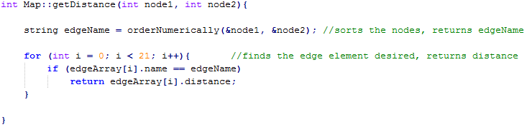
It is important to note that the overloaded function getDistance/Toll/Danger calls an overloaded version of orderNumerically, which returns the proper edgeName in the one case where node 8 and 13 share two edges.

Person Class:
The name of the ‘person’ class was inspired by the fact that people are the objects of interest moving across the graph, and so the relevant movement decisions and algorithms are all stored within this class. Each instance of the Person class instantiates their own maps --- making only one map object and passing it by reference was attempted but due to time constraints and working alone was ultimately abandoned. The constructor takes the starting and end nodes of interest to the person object, and is shown below:
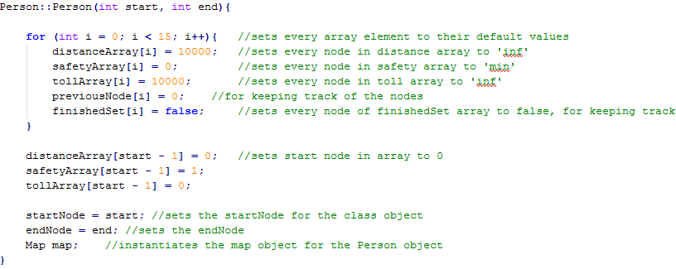
The constructor initializes a lot of arrays which are relevant to Dijkstra's algorithm --- distanceArray, safetyArray, tollArray, and previousNode. distanceArray/safetyArray/tollArray are each respective to their ‘least’ path of interest --- when the shortest path is being considered, distanceArray will be used for Dijkstra's algorithm, cheapest path tollArray, etc. The previousNode array is used to track the path taken from start to end node by using Dijkstra's algorithm to note each node’s ‘quickest’ previous node. To further set up Dijkstra's algorithm, each array’s starting node is set to the min/max value respectively --- so that the algorithm will start from that node location. Each array has 15 elements, which each correspond to the 15 respective nodes on the graph --- element 1 is node 1, and so forth. It is further important to note that the safety array is set to low values, which is different than the distance/toll arrays; this is because of opposite logic for Dijkstra's algorithm being applied here: Instead of Settying every element to ‘infinity’ and starting from 0 distance/toll, instead the safety of the roads is considered, and each element is set to 0 safety in the safetyArray, with the starting node set to 1, being 100% safety.

When coding Dijkstra's algorithm, the following psuedocode from cprogramming’s tutorial proved very helpful:
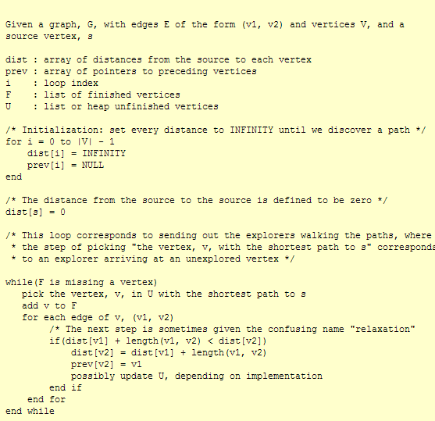
This helped establish most of my understanding to run the algorithm, and is the basis of my leastDistance/Danger/Toll functions. As seen above, the distances of the nodes have been set to ‘infinity’, the previous nodes to 0, and the heap of finished/unfinished vertices handled by the boolean array finishedSet. The starting node is set to 0 in the corresponding arrays, and then the psuedo code is followed further in the leastPath functions of the person class.

The functions leastDistance and leastToll are virtually identical aside from which values they call from the map class, so the leastToll function will be used to explain both:
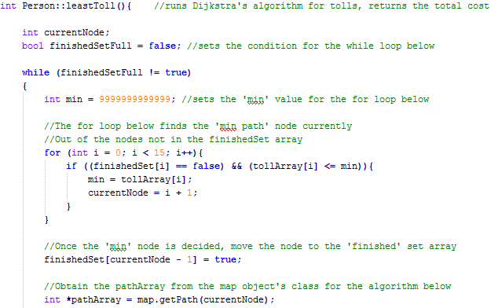
After setting the while loop’s variable condition to false, the while loop initiates Dijkstra's algorithm. At the start of every iteration of the while loop, the “current” node is chosen by iterating through the distanceArray’s elements/nodes and finding the lowest value within the array, setting the ‘currentNode’ for the iteration of the algorithm to be followed by finding the element of the array. After the currentNode is decided, the finishedSet array’s corresponding node element is set to true, as per Dijkstra's algorithm, and the pathArray containing the currentNode’s edge information to other nodes as discussed in the Map class.
The pathArray is key to the later parts of the algorithm: a for loop running through each element of the pathArray will be used to implement Dijkstra's algorithm by checking the respective adjacent nodes and getting the edge information for the distances while comparing them to the current distances of the adjacent nodes, as shown:

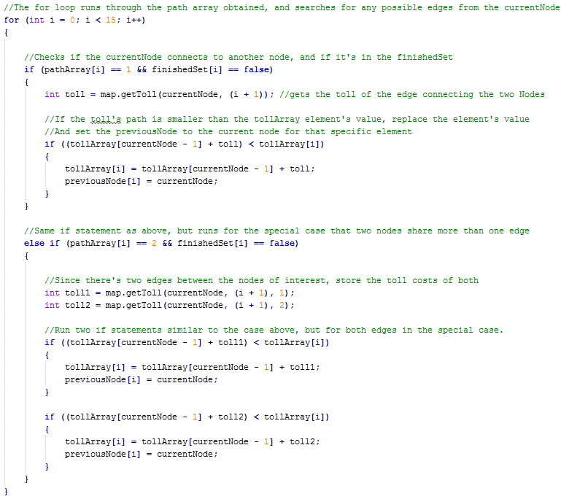
The for loop above runs through the 15 elements of the pathArray, and in the case of an adjacent node, the number of edges will either be 1 or 2, as discussed in the map class; this is compared to the finishedSet array, to see if the adjacent node has reached the lowest value the paths can give --- if it has, the value should be ‘true’ in the finishedSet array, otherwise false. If both these conditions are met, the getToll function is called and the value of the respective edge(s) are stored within the toll variable. Once the value has been obtained, the adjacent nodes’ value is compared to the currentNode + the edge’s values; if the currentNode + edge have an overall lower value for the respective adjacentNode in the tollArray, the tollArray’s node/element is then set to that value, and the previousNode array’s node/element is set to the current Node, such that the node responsible for the shortest path to the adjacent node will be set to the currentNode currently. This is for the printing of the path later.

After all adjacent nodes have been checked and compared, the for loop ends and the while loop condition variable, finishedSetFull, is set to true --- this variable will stay true if every element/node in the graph has been iterated in Dijkstra's algorithm; otherwise it will be set to false, as the for loop right before the end of the while loop checks.
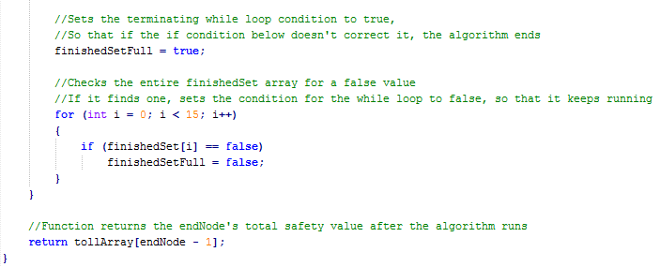
Once Dijkstra's algorithm has finished, the lowest values for the distance/toll path from the respective starting node has been found, the value of the totalToll/Distance of the endNode is returned, so that it may be printed as the shortest length/cost in the Main.cpp .

The leastDanger() function differs from leastDistance/Toll in one way; the way the danger of the nodes/edges are calculated and summed. Since the danger of each edege is the probability of getting an exam along that route, and the probability of not getting an exam is of interest, the danger of each edge must be inverted by the equation (1 – p) , to get the safety of each path: this is why the array in question is named “safetyArray”. Since high safety is the primary concern, namely the chance of not getting any exams at all, the higher the proability of the node, the better --- this is why the initialization of the safetyArray and start node was the opposite of the other two arrays. The complication of probability being used for node values comes along with another difficulty, adding the probabilities properly.
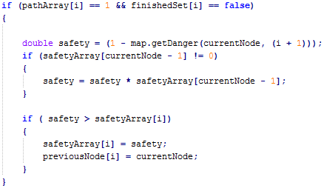
As shown in the code above, the leastDanger function inverts the danger obtained from the getDanger function to the safety of the edge, and runs one more check on the currentNode before checking if the safety of the adjacentNode is less than the currentNode. If the safety of the currentNode of interest is 0, you can just add the safety probability of the respective edge to get the safety of the adjacent edge --- however if it’s not 0, you must multiply the safety of the currentNode and the edge to get the safety of the adjacent node. This condition must be checked for each iteration, otherwise the values will all be largely skewed.
Once the while loop finishes iterating, the leastDanger function returns the double of the probability of not getting an exam of the final node, or the “safety” of the endNode. The probability is not converted to percentages, and is done so by the Main.cpp .

To print the ‘least’ path of the starting and end nodes of interest, a recursive search is followed from the endNode to the startNode of the person object via the previousNode array:
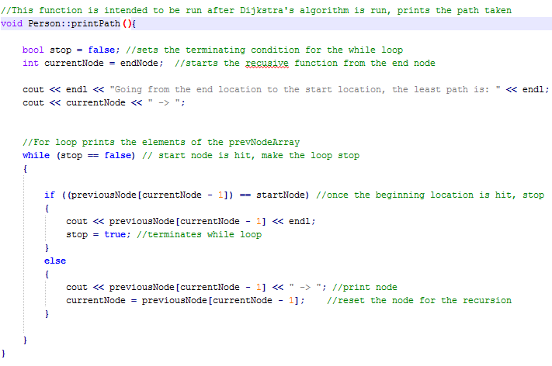
The “printPath” function shown above runs through the endNode’s element of the prevNode array, which stores the node which had the ‘least’ path to the element of the array, until it hits the startNode element. Once it has hit that, it terminates. An effective way for printing the path and avoids using a vector, but it prints the path backwards. An example of the printPath’s output is shown below:

Main.cpp:
Fairly straightforward, this instantiates the 4 person objects with the proper start and end nodes for the 4 problems addressed and prints out the proper results:
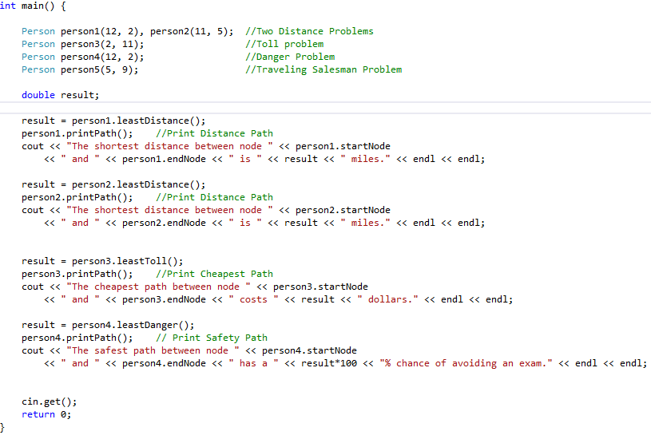
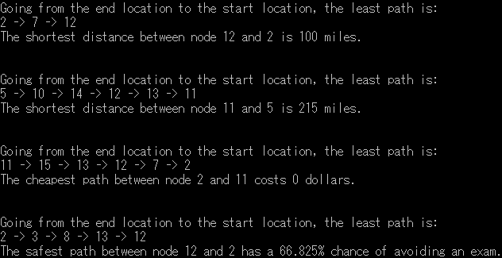

Traveling Salesman Problem:
Unfortunately the 5th problem could not be addressed due to time constraints and working alone. The traveling salesman-esque problem was planned to be tackled by looking at the adjacent nodes of the current position , looking 3 steps and all trees ahead of that for nodes not yet visited in a rather complex fashion, and going to the node not yet visited selected somewhat intelligently out of the results. If the results returned that all nodes were visited, a random node would be chosen, and so forth. The problem is that it’s complicated to compile such a code under such time constraints, and another main concern was that the code might loop indefinitely if the randomness was not properly integrated within the system.

References

- http://www.geeksforgeeks.org/greedy-algorithms-set-6-dijkstras-shortest-path-algorithm/
- http://www.cprogramming.com/tutorial/computersciencetheory/dijkstra.html

